**Sky Clash: Rock vs. Goose - Game Design Document**

## **Game Title**

Sky Clash: Rock vs. Goose

## **Game Purpose/Genre**

Sky Clash is a fast paced strategic and skill based game for two players. This game focuses on fast reaction time, planning, and quick inputs.

## **Target Audience**

Sky Clash is targeted towards players aged 10 and up who like fast-paced, strategic games. No real experience is required, as the controls are easy to pick up and understand. It is particularly suited for those who like games that require both strategy and reactions.

## **Platform and Technology Requirements**

Platform: Any computer that has Python and Pygame installed

## **Entertainment Software Rating Board (ESRB) Game Rating**

ESRB Rating: Everyone 10+ (E10+) - The game contains minor violence that is suitable for ages 10 or older.

## **Game Description**

Sky Clash involves two players, a goose and a rock that fight in the air. The objective of the goose is to hold out for long enough without getting hit, and can grab power ups that influence their speed, or can grant a shield. The objective of the rock is to try and hit the goose as many times as possible. The game arena is an open area in the sky that the two players battle on.

## **Level Design (Storyboard)**

The game is set on one stage, where everything takes place. The background consists of a mountain range.

## **Graphics**

Goose: Art was made by me, so no credit is required.



Rock: Art was also made by me, so no credit is required.



Background: Made by me, so no credit is required.



Power up: Also made by me



Game Layout:

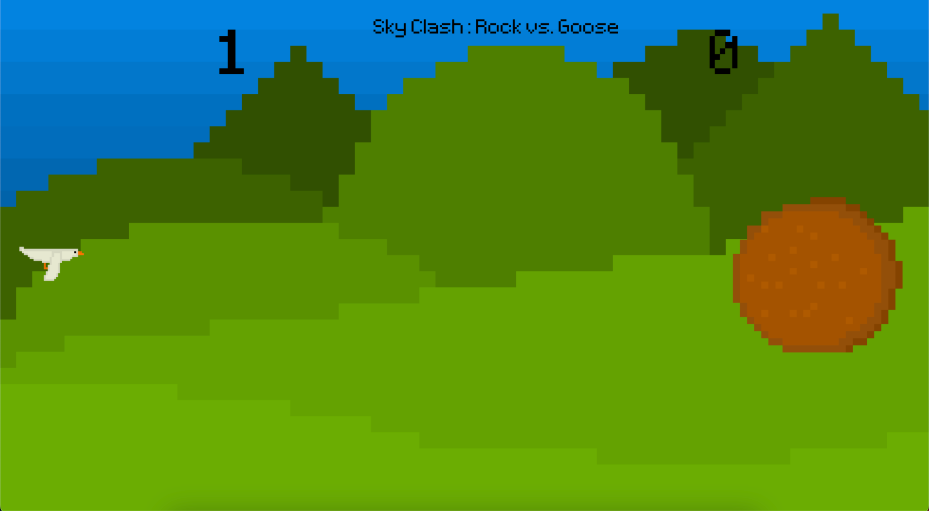

## **Characters and Objects with Behaviors**

* Goose (Player 1):
  + Controls: WASD to move all around the playing field
  + Behavior: None, just dodge!
* Rock (Player 2):
  + Controls: up and down arrow keys for movement, and space to throw a rock.
  + Behavior: When clicking space, a rock is created and is sent to the left towards the goose. There is a cooldown so the rock must play strategically to trap the goose

## **Instructions for Players**

* Rock Instructions:
  + Use the Spacebar to send a rock towards the left.
  + If you hit the goose, you score a point.
* Goose Instructions:
  + Use WASD to move around the playing field.
  + Fly through power ups to gain special abilities
  + After 10 seconds without getting hit, you will score a point

## **Scoring, Win/Lose Conditions, and Objectives**

* Scoring: After 10 seconds of not getting hit, the goose scores a point, if they’re hit, the rock scores a point.
* Win Conditions:
  + The game can go on as long as the players want, the winning score is determined at the beginning of the game.

## **Additional Notes**

* The game features simple 2D graphics with a side view, to improve aerial maneuvering.